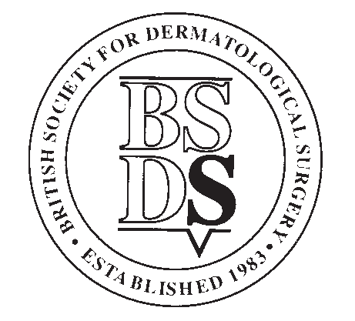

BRITISH SOCIETY FOR DERMATOLOGICAL SURGERY
Medical Student Patient Information Leaflet (PIL) and Essay Prize Application Form, January 2024
Applicants Details
Forename
Surname
Year of Study
Contact Address
Post Code
Telephone
Email
Contact details for member of staff at your medical school registry:
Applicants’ student status will be confirmed with the medical school before prize is awarded
Name
Position
Name of Medical School
Email
Telephone
Please see overleaf for conditions of entry.
The closing date for applications is 31th January 2024.
Application forms must be submitted along with your essay and PIL to info@bsds.org.uk

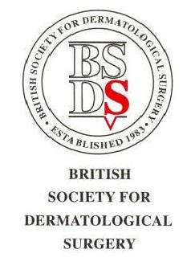

BSDS Medical Student PIL and Essay Prize

Conditions

- The BSDS Medical Student PIL and Essay Prize is open to any individual who has medical student status at the time of application or who graduates in 2024.

- All documents must be the applicant’s own work and be on the subject determined by the BSDS Executive Committee.

- Patient information leaflet (PIL) to be composed in plain English standard with a readability age of 9. Typed in 12-point size (ariel font preferred) with double line spacing. No more than 2 images. Maximum word count of 1500 (excluding references) No more than 10 references. The PIL should be submitted electronically in word or another editable and compatible format. (Not PDF please)

- Accompanying Essays should be no longer than 500 words (excluding tables and references) and should be typed in 12-point size (ariel font preferred) with double line spacing. Essays should be submitted electronically in word or another editable and compatible format. (Not PDF please)

- To apply, applicants should submit their patient information leaflet (PIL), essay and application form to: info@bsds.org.uk

- The deadline for applications will be 31st January 2024 at 11.59pm.

- The prize will be: £300

- Winners may be invited to give a presentation at one of the BSDS meetings and will have their PIL and essay published on the BSDS website and social media.
- Applicants’ student status will be confirmed with the medical school before prize is awarded.

Marking Criteria

Your essay will be judged on the following criteria:

- Content (20)
- Originality (10)
- Style/Structure (10)
- Relevance to Dermatological Surgery (10)

